WEB TERMINOLOGIES
- WEB : it is interconnection of public websites which can be accessible through internet
- INTERNET : It is system of interconnected computer networks that allows users to access and share the information
- BROWSER : It is a standalone application through which we can access data with a help of internet and runs the websites for output
- SERVER : It is a combination of software and hardware that receives request and response to a request over a network
- WEBPAGES : It is document that is accessible by browser and it contains text, images, hyperlinks and these are also called as building blocks of websites
- WEBSITES : It is collection of related or interconnected webpages

HOW WEB APPLICATION WORKS???
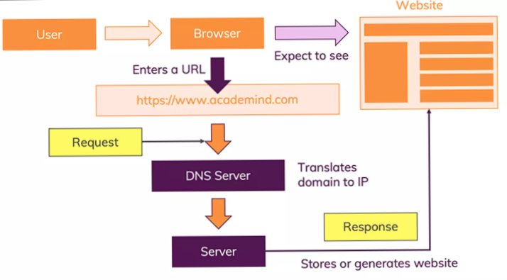

DIFFERENCE BETWEEN STATIC AND DYNAMIC WEBSITES
Static Website | Dynamic Website
- User can’t modify the content  - Contents is same to all the user and same.  - Is has less reloading time.  - Only single component will reload  - Most of multi-page applications are static website  - Ex : Geeks for geeks | - User can modify the content.  - Content is different to all the user and different to individual user.  - Comparatively more reloading time.  - The whole website will get reload  - Most of single page application are dynamic website  - Ex : Instagram, Facebook

History of HTML
HTML came from the origin language XML
HTML was introduced in 1989 by Tim Berners Lee
First version of HTML is released in 1991—html 1.0
Html 2.0----1993
Html 3.2----1995
Html 4.2----1997
Html 5.0----2014
Current version of html means now we are using html 5.0

WHAT IS HTML???
HTML is hypertext markup language as well as Root front end language and reference or link to visualize the content or data on user interface by using predefined tags which are browser understandable
STRUCTURE OF HTML
<! DOCTYPE html>
<html lang="en">
<head>
<meta charset="UTF-8">
<meta name="viewport" content="width=device-width, initial-scale=1.0">
<title>Web Development</title>
</head>
<body>
</body>
</html>

DOCTYPE TAG:
It is declaration of document type which version we are using currently (HTML 5) and declaration is an instruction to the web browser about what version of HTML the page is written in.
HTML TAG:
It is a root tag of html and also it holds the language attribute
HEAD TAG
Head tag will store meta data in the form of meta tag which will consist of some inbuilt characteristics, Unicode (UTF 8) and properties of device (it holds 2 meta tags) and the content written in head tag will not visible to the browser

BODY TAG
The content or the structure we can write here by using all types of tags
HTML TAGS
Tag ---- it is a term or predefined word which will enclosed within angular braces
Ex ... <> </> and <>
Two types of tags in html
1. Paired tag: it will be having a partner or pair along with and between the two tags we will write the content
Ex..... <p> </p>, <body> </body>

2. Unpaired tag: it don’t have partner or pair along with him also called self-closing tag
Ex..... <img>, <link>, <input>

BASIC TAGS OF HTML
1. p tag ---- it is called as paragraph to write paragraph content
2. heading tags ---- from h1 to h6 we have heading tags
3. pre tag ---- The <pre> tag defines preformatted text. The text will be displayed exactly as written in the HTML source code.
4. div tag ---- it acts like container. all html element we can store into this tag
div is block level element
5. span tag ---- it acts like inline container span is inline level element

HTML ELEMENTS
The content enclosed between a tags called HTML elements
Block Level Elements:
A block-level element always starts in a new line and it occupies the whole horizontal space of its parent element & the height is equal to the content’s height.
Inline Elements:
An inline element is the opposite of the block-level element. It does not start in a new line and takes up only the necessary instead of breaking the flow of the content.

DIFFERENCE BETWEEN INLINE AND BLOCK ELEMENTS
Inline Elements | Block Elements
Inline elements occupy only sufficient width required. | Block Elements occupy the full width irrespective of their sufficiency.
Inline elements don’t start in a new line. | Block elements always start in a line.
Inline elements allow other inline elements to sit behind. | Block elements doesn’t allow other elements to sit behind
Inline elements have top and bottom margin | Block elements don’t have top and bottom margin.

HTML ATTRIBUTES
It is an added extension into html tag.
HTML attributes provide additional information about HTML elements.
Attributes written inside always opening tag of html element
Ex. Attribute = “ attribute value”;

Two types of attributes in HTML
1. Core or global attribute
2. Element specific attribute
* Core attributes
1. style -------- to style our html element
2. title -------- it will create an tool tip for html element
3. Id ---------- it will target html element for css and id should be unique
4. Class ------- it will target html element for css but class can be same

* Element specific attribute
thease type of attribute will use in some specific types of tags
ex : href ---------- in anchor tag
src and alt---- in img tag

FORMATTING TAGS
These tags will change the appearance of html element and adds visual enhancement to the text
1. b tag - it will provide some solid weight to the content
2. Strong tag -it will provide some solid weight to the content and with more importance
3. i tag - it will make content slightly bend towards forward direction
4. em tag - it will make content in italic form
5. u tag - it will add one underline to the content
6. ins tag - it will add one underline to the content
7. strike tag - it is deprecated tag . Will give over through line to content
8. mark tag - it will make the content highlighted
9. sup tag (superscript tag) - it will moves content slightly upward direction
10. sub tag (subscript tag) - it will moves content slightly downward direction
11. q tag - it will add quotation to the content (“ ”)
12. center tag – it will make your content center horizontally and its deprecated one

13. marquee tag – it will make your content to be run from one side till another side
And in this tag you will get behavior and direction attribute as well as scrollamount attributue

SEMANTIC TAGS (ELEMENTS)
A semantic element clearly describes its meaning to both the browser and the developer.
Examples of non-semantic elements: <div> and <span> - Tells nothing about its content.
Most of semantic elements are block level elements.
Examples of semantic elements: <form>, <table>, and <article> - Clearly defines its content
Semantic elements represents their meaning to both the browser and developer.
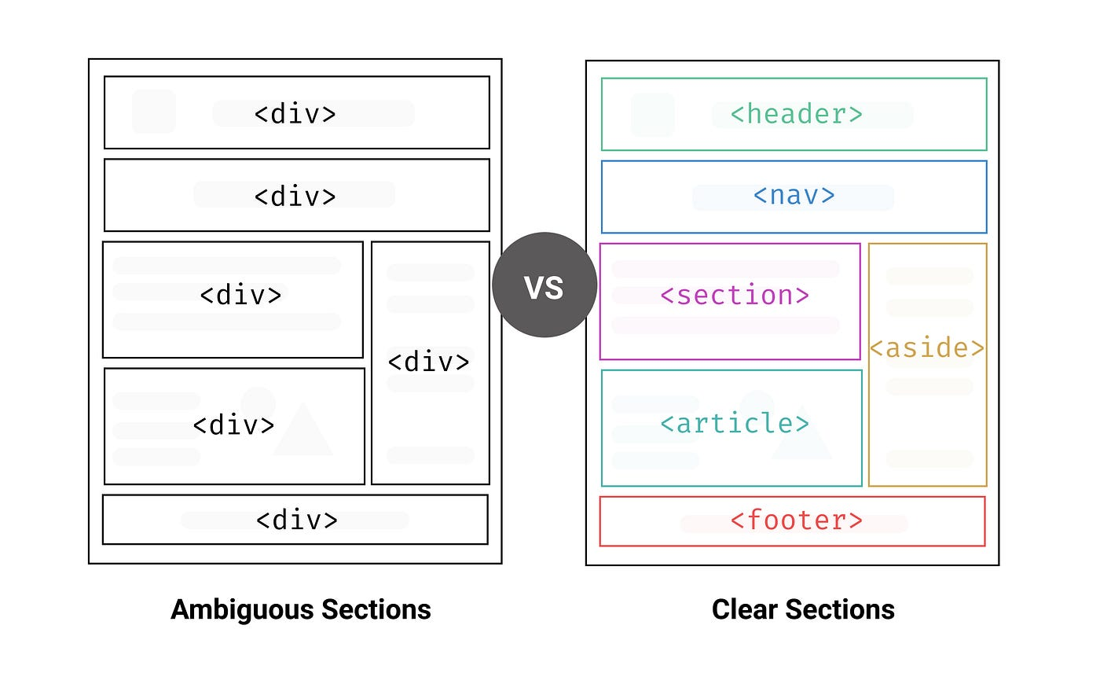

SOME SEMANTIC ELEMENTS ARE:
H - HEADER
The <header> element represents a container for introductory content or a set of navigational links.
D – DETAILS
The <details> tag specifies additional details that the user can open and close on demand. The <details> tag is often used to create an interactive widget that the user can open and close. By default, the widget is closed. When open, it expands, and displays the content within. Any sort of content can be put inside the <details> tag.
A==ASIDE
The <aside> tag defines some content aside from the content it is placed in.
M==MAIN
The <main> tag specifies the main content of a document. The content inside the <main> element should be unique to the document. It should not contain any content that is repeated across documents such as sidebars, navigation links, copyright information, site logos, and search forms.
N==NAV
The nav element represents a section of a page that links to other pages or to parts within the page: a section with navigation links.
S== SECTION
The <section> element is a structural HTML element used to group together related elements. Each <section> typically includes one or more heading elements and additional elements presenting related content.
T ==TABLE
To create table we use table tag.

A ==ARTICLE
tag specifies independent, self-contained content.
F==FOOTER:
The <footer> element is a structural element used to identify the footer of a page, document, article, or section. A <footer> typically contains copyright and authorship information or navigational elements pertaining to the contents of the parent element.
F== FORM : To create form in html we use form tag.

LIST CREATION
The content or information written below to other or row by row
Four types of list
ORDERED LIST
The ordered list can be written in two orders like numerical or alphabetical manner
ol tag - root tag of ordered list
li tag - to write list items

ORDERED LIST ATTRIBUTES
type - what type of order we need to mention
Ex. 1 ( default ), A ,a , I , i
start - from which order list has to be start ( number )
reversed - to make order in reverse
Ex :
<ol type="1" start="10" reversed>
<li>tomato</li>
<li>onion</li>
<li>carrot</li>
<li>beat root</li>
<li>cucumber</li>
</ol>

UNORDERED LIST
Unordered list - the content written in bulleted or marked order
Ul tag - root tag of unordered list
UNORDERED LIST ATTRIBUTES
type - what type of style of order we need to mention
Ex. Disc ( default ) , circle , square , none
Ex :
<ul type="disc">
<li>bikes</li>
<li>bikes</li>
<li>bikes</li>
</ul>

DESCRIPTION LIST
This list makes the groups of list in their respective terms
dl tag - root tag of description list
dt – description term
dd – description data
Ex :
<dl>
<dt>cars</dt>
<dd>Mg hector</dd>
<dd>thar</dd>
<dd>benz</dd>
<dt>bikes</dt>
<dd>Bullet</dd>
<dd>Harley</dd>
</dl>

NESTED LIST
A list inside another list is called nested list

TABLE CREATION
Table is logical structure of having rows and columns to store the data in specific manner
<table></table> tag is root tag to create table
tr tag ------ is used to create table rows
th tag ------- is used to add table headings
td tag -------- is used to add table data

Table tag attributes
Border ------- to provide the border for table in pixels. Default will be 2pixels
cellpadding ------- the space between table data and table cell border . it will increase the size of each cell in table
cellspacing ------- the space between two different cells
Note : border , cellpadding and cellspacing attributes written inside table tag

rowspan --------- to merge two or more rows and rowspan attribute have to provide in respective td or th tag from where we have to merge the rows till where we have to
ex. Rowspan = “5”
if you given value like this 5 rows will be merged
colspan --------- to merge two or more columns. colspan attribute have to provide in respective td or th tag from where we have to merge the columns till where we have to
ex. colspan = “3”
if you given value like this 3 columns will be merged

IMAGE HANDLING
The HTML <img> tag is used to embed an image in a web page.
Images are not technically inserted into a web page; images are linked to web pages. The <img> tag creates a holding space for the referenced image.
The <img> tag is empty, it contains attributes only, and does not have a closing tag.
The <img> tag has two required attributes:
- src - Specifies the path to the image
- alt - The required alt attribute provides an alternate text for an image, if the user for some reason cannot view it (because of slow connection, an error in the src attribute)
- height and width attribute – to set height and width of image according to our requirement we will use these attributes
Absolute url v/s Relative url
a full web address in the src attribute.
<img src="https://www.w3.organiasation.com">

A local link (a link to a page within the same website) is specified with a relative URL (without the "https://www" part):
<img src="./ html_images.asp">

ANCHOR TAG
The HTML anchor tag it converts hypertext into hyperlink that links one page to another page.
The "href" attribute is the most important attribute of the anchor a tag. and which links to destination page or URL.
Syntax of HTML anchor Tag given below:
<a href=“…… ”> link text </a>
Appearance of anchor links
By default, links will appear as follows in all browsers
- An unvisited link is underlined and purple
- A visited link is underlined and blue
- An active link is underlined and red

Ways to link anchor tag
Text as a Link
To use an text as a link, just write the text inside the <a> tag with href attribute
Image as a Link
To use an image as a link, just put the <img> tag inside the <a> tag:
Button as a Link
To use a button as a link, just put the <button> tag inside the <a> tag:
Icon to link
To use an icon as a link, just put the i tag with respective icon inside the <a> tag:

TARGET ATTRIBUTE IN ANCHOR TAG
By default, the linked page will be displayed in the current browser tab. To change this, you must specify another attribute that is target for the link.
The target attribute specifies where to open the linked document.
The target attribute can have one of the following values:
_self - Default. Opens the document in the same window/tab as it was clicked
_blank - Opens the document in a new window or tab
_top - opens the document in top of window
_parent - opens the document in parent web page

FORM CREATION
The <form> Element
The HTML <form> element is used to create an HTML form for user input
The <form> element is a container for different types of input elements, such as: text fields, checkboxes, radio buttons, submit buttons, etc.
The <input> Element
The HTML <input> element is the most used form element.
An <input> element can be displayed in many ways, depending on the type attribute.
Ex:
- <input type="text">
- <input type="radio">
- <input type="checkbox">
- <input type="button">
- <input type="submit"> and so on………..

Basic tags of form creation
1. input tag ---- it is unpaired tag and defines an input control and also an type
2. label tag ----- to mention a label for respective input
3. textarea ------ Defines a multiline input control (text area)
4. fieldset ------Groups related elements in a form
5. legend --------Defines a caption for a <fieldset> element
6. select ---------Defines a drop-down list
7. optgroup ------Defines a group of related options in a drop-down list
8. option -------- Defines an option in a drop-down list
9. button ---------- Defines a clickable button

Basic attributes of form
type ------- it will specify which type of data we should enter
for and id ------- for in label tag and id in input tag. To connect the label tag and respective input tag
name ------ the attribute specifies the result in navigator after submission of form
value ------ the attribute specifies the validation for different types of type

VALIDATION ATTRIBUTES OF FORM
Value: The input value attribute specifies an initial value for an input field
Readonly: The input readonly attribute specifies that an input field is read-only.
Disabled: The input disabled attribute specifies that an input field should be disabled.
- A disabled input field is unusable and un-clickable.
Size: The input size attribute specifies the visible width, in characters, of an input field.
- The default value for size is 20
- Note: The size attribute works with the following input types: text, search, tel, url, email, and password.
Maxlength: The input maxlength attribute specifies the maximum number of characters allowed in an input field.
Min & Max: The input min and max attributes specify the minimum and maximum values for an input field.
Placeholder: The input placeholder attribute specifies a short hint that describes the expected value of an input field (a sample value or a short description of the expected format).
Required: The input required attribute specifies that an input field must be filled out before submitting the form.
Pattern: this attribute specifies the valuable password for password type and it has syntax like pattern=”[A-Za-z0-9]{8}” number of digits you want ex. 8 digits of password
Height & Width: The input height and width attributes specify the height and width of an <input type="image"> element.

MEDIA TAGS
Multimedia on the web is sound, music, videos, movies.
HTML media consist of audio, video, maps and QRcode.
Audio:
<audio> tag is used to embed the audio into our web page.
The content which is written inside <audio></audio> will not displayed on the webpage
Attributes of audio tag:
Src : we will pass path of audio.(relative path -- good practice)
Controls : The controls attribute adds audio controls, like play, pause, and volume
Muted : It will mute the audio when you open your file with browser
Autoplay: It will play the audio automatically when you open your file with browser.
Loop : The audio will start over again , every time it is finished.

VIDEO TAG :
<video> tag is used to embed the video into our web page.
The content which is written inside <video></video> will not displayed on the webpage

Attributes of video tag:
Src : we will pass path of video.
Controls : The controls attribute adds video controls, like play, pause, and volume
Muted : It will mute the video when you open your file with browser
Autoplay: It will play the video automatically when you open your file with browser.
Loop : The video will start over again , every time it is finished.

IFRAME TAG:
<iframe> tag is used to embed the another document within the current HTML document.
An HTML iframe is used to display a web page within a web page.
The HTML <iframe> tag specifies an inline frame.
Height and width attributes are used to specify the height and width of the iframe
Title attribute is used to give the title for the iframe

GENARATING QR CODE
We can insert a qr code to our webpages using <img> tag.
Syntax
Root URL:
https://chart.googleapis.com/chart?

cht=qr& : (QR code type)
chs& : width x height (height and width)
chl= : chat link (path or link)

CSS
CSS stands for Cascading Style Sheet.
Gives Styling to the Web Pages.
Cascading means – poring (adding)
Poring css styling on to HTML document
Style sheet – Document

HISTORY OF CSS
css invented by hykowm wiem lie in 1994
CSS 1 – 1996
CSS 2 – 1998
CSS 3 – 2007
Currently we are using css 3
New features in css 3 are below :
Media querries, text effects, gradients , css grid , flex , Opacity , selectors , animations , borders , layout , transforms , shadows

CSS Syntax:
Tag name or selectors {
css properties : value ;
}

3 WAYS TO ADD CSS IN HTML
- Inline CSS
- Internal CSS
- External CSS
Inline CSS
The code is written in the opening tag of the HTML element by using style attribute.
Syntax:
<p style=“property : value”> content </p>
Internal CSS
The code is written inside or after head tag section of an HTML element by using <style> tag.
Syntax:
</head>
<style>
tag_name{
property: value;
}
<style>
External CSS
External CSS styling can be done by creating a external CSS file with file_name.css extension and providing the link between that CSS file to HTML file by <link> tag in the head section of HTML element.
Syntax:
<head>
<link rel="stylesheet" href=" file_name.css">
</head>
NOTE:
rel : specifies the relation. rel=“stylesheet” No value other than “stylesheet” should be declared

CSS SELECTORS
Selectors are used to select or target the particular HTML element to style them.
There are five types of Selectors:
- Simple Selectors.
- Combinator Selectors.
- Attribute Selectors.
- Pseudo Class Selectors.
- Pseudo Element Selectors.

SIMPLE SELECTOR
Simple selectors style the HTML element in five ways:
- Id Selector.
- Class Selector.
- Tag name selector
- Grouping selector
- Universal selector

Id selector
Id selector targets only individual element in the HTML document.
Prefix symbol used for id selector is # (hash) id should be unique

HTML file CSS file
#demo {
color: red;
background: yellow;
}
<p id=“demo”>HELLO</p>

Class selector
Class selectors targets multiple elements in the HTML document.
Prefix symbol used for id selector is . (dot) class can be multiples
Syntax :
HTML CSS
.test{
color: magenta;
background: green;
}
<h1 class=“test”>HELLO</h1>
<h2 class= “test”>GOOD</h2>
<h3 class= “test”>MORNING</h3>

Tagname selector
Tagname selector targets the HTML elements by tag name.
There is no symbol used in tagname selectors.
Syntax
h1{
color: magenta;
background: green;
}
h2{
color: red;
background: black;
}
h3{
color: yellow;
background: orange;
}

<h1>HEADING 1</h1>
<h2> HEADING 2 </h2>
<h3> HEADING 3 </h3>

Grouping selector
Grouping selector targets a group of HTML elements by tagname separated by commas.(,)
Syntax :
p, div, h4{
color: magenta;
background: green;
}
<p>Paragraph</p>
<div>Division</div>
<h4>HEADING 4</h4>

Universal Selectors
Universal Selectors targets every HTML element. The symbol of Universal Selector is *
Syntax :
*{
color: yellow;
background: magenta;
}
<p>Paragraph</p>
<div>Division</div>
<h4>HEADING 4</h4>

COMBINATOR SELECTOR
Combinator Selectors are used to style the combination of HTML elements.
- Descendent selector
- Child selector
- Adjacent selector
- General sibling selector

Descendent Selectors: This Selector targets both direct and indirect children of a parent tag.
The symbol is (space)
Syntax: parent_tag child tag{
Property: value;
}
Child Selectors: This Selector targets the only the direct children of the parent

The symbol is > (greater than)
Syntax: parent_tag > child_tag{
property: value;
}
3. Adjacent Selectors: This Selector targets the element which is the first sibling of the targeted HTML tag or element. (or) This Selector targets the element which is exactly adjacent to the targeted HTML tag or element
The symbol is + (plus)
Syntax: first_sib tag + second_sib tag{
property: value;
}
4. General Sibling Selectors: This Selector targets all the siblings of the target HTML tag or element.
(or) This Selector targets all the adjacent tags of the target HTML tag or element.
The symbol is ~ (tilde)
Syntax: first_sib tag ~ second_sib tag{
property: value;}

ATTRIBUTE SELECTORS
Attribute selectors are used to style the HTML element by targeting the respective attributes and with their values.
Types of Attribute Selector:
1. tag_name[attribute_name] :
Represents elements with an attribute name of attribute_name.
2. tag_name [ attribute_name= “value” ] :
Represents element with an attribute name of attribute_name whose value is exactly value.

PSEUDO ELEMENTS SELECTORS
For pseudo elements selectors will target by (::) this symbol
- First Letter : it will target the first letter of respective content of targeted html element
- First Line : it will target the first line of respective content of targeted html element
- Before : it will add the any type of content or css property just before the targeted html element
- After : it will add the any type of content or css property right after the targeted html element
- Selection : whenever we will select any kind of content will get color as blue as default but by using selection slector we can change that color and background color to
- Marker : this selector will change the color of list marker and only it will applicable for li tag

PSEUDO CLASS SELECTORS
1. Dynamic pseudo class
2. Structural pseudo class
Dynamic pseudo class
- hover

p:hover {
background-color: aqua;
}

<p>rohit</p>

- visited
a:visited {
color: aqua;
}

<a href=”” >rohit</a>

- Active
a:active {
background-color: aqua;
}

<a href="">click here</a>
- focus
input:focus {
background-color: aqua;
}

<input type=”text”>

Structural pseudo class
- First-child
div p:first-child {
background-color: aqua;
}
<div>
<p>child 1</p>
<p>child 2</p>
<p>child 3</p>
<p>child 4</p>
<p>child 5</p>
</div>

output -----> child1

- Last-child
div p:last-child {
background-color: aqua;
}
<div>
<p>child 1</p>
<p>child 2</p>
<p>child 3</p>
<p>child 4</p>
<p>child 5</p>
</div>
output -----> child5

- Nth-child
div p:nth-child(4) and for even child’s (2n) and for odd child’s(2n-1){
background-color: aqua;
}
<div>
<p>child 1</p>
<p>child 2</p>
<p>child 3</p>
<p>child 4</p>
<p>child 5</p>
</div>
output -----> child4

- First-of-type
div b:first-of-type {
background-color: aqua;
}
<div>
<p>child 1</p>
<b>bold1</b>
<p>child 2</p>
<b>bold2</b>
<p>child 3</p>
<b>bold3</b>
</div>

output -----> bold1

- Last-of-type
div p:last-of-type {
background-color: aqua;
}
<div>
<p>child 1</p>
<b>bold1</b>
<p>child 2</p>
<b>bold2</b>
<p>child 3</p>
<b>bold3</b>
</div>

output -----> child3

BOX MODELLING
Box Model is essentially a box that wraps around every HTML element
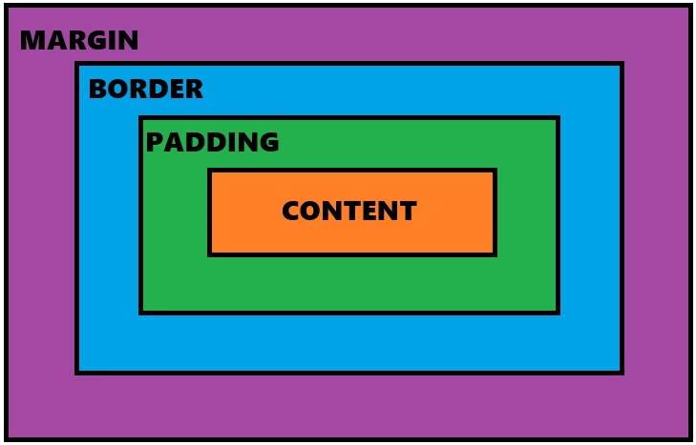

Box Model is used to design and layout.
The CSS Box Model consists of Margin, Border, Padding and the actual Content.
Content: It is the content of the HTML element.
Padding: It is the space after the content.
Border: It is the Border of the HTML element.
Margin: It is the space after the Border of an HTML element.
Padding and Margin allow up to four values.
Syntax:
T R B L
padding: 10px 0 0 0;
padding: 10px 20px 0 0;
padding: 10px 20px 30px 0;
padding: 10px 20px 30px 40px;

Text formatting properties:
- Color - font color
- text-align – center , right , left , justify
- text-transform – capitalize , uppercase , lowercase
- text-shadow – px px px color ;
- text-decoration – underline , overline , overthrogh , none
- letter-spacing – in pixels
- word-spacing – in pixels
- line-height – in pixels
Font properties:
- font size : in pixels , small ,smaller, medium , large , larger , xxlarger
- font style : italic , oblique, normal
- font family : like times new roman
- font weight : 100- 900 (boldness)

CSS COLORS
Hexa:
#000000 Black (0-9)
#ffffff White (a-f)
RGB: (red green blue)
rgb(255,0,0) red
rgb(0,255,0) green
rgb(0,0,255) blue
RGBA: (red green blue alpha)
alpha(opacity): 0.0 transparent
1.0 Totally visible
HSL: (hue, saturation, lightening)
Hue deg
Saturation %
Lightening %
HSLA: (hue, saturation, lightening, alpha)

CSS BACKGROUND PROPERTIES
background color
To add background color in HTML, use the CSS background-color property. Set it to the color name or code you want and place it
Background:
The only background property we will use for adding mix-up of two or more colors in 3 ways
Linear – gradient: it adds two or more colors by horizontally
Radial - gradient: it add two or more colors from middle point to around all rounded surface
Conic – gradient: it will add two or more colors from center pointer of html element in shape or triangle like ex. CD DVD shape
background image
The most basic way to set a full-page background is to use the CSS background-image property. This property accepts a value that is the URL of the image you want to use as the background.
Background size
We can set the background image size with the help of this property The background-size property is specified in one of the following ways:
Using the keyword values contain or cover. Using a width value only, in which case the height defaults to auto. Using both a width and a height value, in which case the first sets the width and the second sets the height.
background position
The background-position property sets the starting position of a background image. Tip: By default, a background-image is placed at the top-left corner of an element
background attachment
The background-attachment property sets whether a background image scrolls with the rest of the page, or is fixed. values are scroll and fixed
background repeat
The background-repeat property sets if/how a background image will be repeated. By default, a background-image is repeated both vertically and horizontally. Tip: The background image is placed according to the background-position property.
Values : repeat , no-repeat , repeatX, repeatY

BORDERS AND BOX EFFECTS PROPERTIES
Border properties:
Border : Border property will provide different types of borders to html element
Border: 2px solid black; (shorthand pr]operty)
2px – thickness of border
Solid – style type of border. Solid is default (style of border is mandatory. Some more styles of border are - dashed, dotted, double, groove, ridge and outset)
Black – color of border
We can provide each and individual properties:
Border-top-width Border-top-style Border-top-color
Border-right-width Border-right-style Border-right-color
Border-bottom-width Border-bottom-style Border-bottom-color
Border-left-width Border-left-style Border-left-color
Box shadow
The box-shadow CSS property adds shadow effects around an element's frame.
box shadow : 5px 5px 5px 5px red;
Specify a Horizontal and a Vertical Shadow. In its simplest use, you only specify a horizontal and a vertical shadow
Add a Blur Effect to the Shadow
Set the Spread Radius opacity of the Shadow
Specify a Color for the Shadow. The color parameter defines the color of the shadow.
overflow property
The overflow property specifies what should happen if content overflows an element's box.
This property specifies whether to clip content or to add scrollbars when an element's content is too big to fit in a specified area.
values
hidden , scroll
resize property
The resize property defines if (and how) an element is resizable by the user. Note: The resize property does not apply to inline elements where overflow="visible". So, make sure that overflow is set to "scroll", "auto", or "hidden".
Values
horizontal , vertical , both
Visibility property
This property makes the content visible or hidden according to the its values the values are given in visibility properties are visible and hidden
image border
The border-image property allows you to specify an image to be used as the border around an element. for applying image in border border property is mandatory
Ex : border-image : url(./img.jpg) 50 ;
outline property
An outline is a line that is drawn around elements, OUTSIDE the borders, to make the element "stand out"
CSS has the following outline properties:
outline is the shorthand properties for below properties
outline-style
outline-color
Outline-width
outline-offset

POSITIONS IN CSS
Relative
The position of the element is relative to the normal position, where the
white space of the targeted element is not occupied by the other element
Absolute
When the position is absolute the element can be placed anywhere on
the webpages, where the white space of that element is occupied by the
other element.
Fixed
The position of the element depends on the viewport of the browser’s
Window and it will be fixed on the webpages
Sticky
The targeted element is sticked to the position based on the scrolling of
the web page.

DISPLAY PROPERTIES
Flex property
The most flexible display property in CSS is the apparently named as display: flex, which allows you to create flexible layouts with elements that you can align and distribute horizontally
display : flex ;
In parent container this property have to provide to create layout in one line
align items –
this property will make elements center of the webpage
center , start and end
justify content - The justify-content property aligns the flexible container's items when the items do not use all available space on the main-axis (horizontally).
justify content property values :
center Items are positioned in the center of the container
space-between Items will have space between them
space-around Items will have space before, between, and after them
space-evenly Items will have equal space around

Grid Property
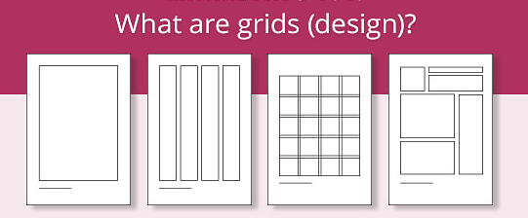
The CSS grid layout module excels at dividing a page into major regions or defining the relationship in terms of size, position, and layer, between parts of a control built from HTML primitives. Like tables, grid layout enables an author to align elements into columns and rows.
Grid property is a shorthand and parent property for the following properties:

Properties values (just examples)
grid-template-columns : auto auto auto auto (or)10px 20px 45px 85px
Will mention how many columns we want have in grid layout by specifying above values
grid-template-rows : auto auto auto auto (or)10px 20px 45px 85px
We can mention how many rows we want have in grid layout by specifying above values
grid-template-rows : repeat(4, 1fr)
grid-template-columns : repeat(4, 1fr)
repeat() function : we can declare how many rows or columns we want by giving value instead of mentioning in auto and pixels for ex . 4 means 4 rows or columns get created
FR unit in grid : fractional unit . it takes the even space according to the parent width and height
gap : in pixels. Also we have individual rowgap and colgap

grid column start & grid column end
We can merge the 2 or more columns by giving thease properties
By starting value and at the end we have to give one extra value for merging
Ex. Like if you are merging 3 columns from start you have to mention
grid column start : 1 & grid column end : 4 like (n+1 formula)
Note : for rows also same formula will be added

TRANSFORM PROPERTY
The CSS transform property allows you to rotate, scale, skew, and translate an element. It modifies the coordinate space of the CSS visual formatting model.
CSS transform property allows you to modify an element's shape, size, position, and orientation.
Translate property in CSS
The translate property allows you to change the position of elements. The translate property defines x- and y-coordinates of an element in 2D
translate() Defines a 2D translation
translateX() Defines a translation, using only the value for the X-axis
translateY() Defines a translation, using only the value for the Y-axis

Scale property
The scale property in CSS resizes an element's width and height in proportion. So, if we have an element that's 100 pixels square, scaling it up by a value of 2 doubles the dimensions to 200 pixels square
scale() Defines a 2D scale transformation
scaleX() Defines a scale by giving a value for the X-axis
scaleY() Defines a scale transformation by giving a value for the Y-axis
Rotate property
The rotate property allows you to rotate elements. The rotate property defines a value for how much an element is rotated clockwise direction
rotate(angle) Defines a 2D rotation, the angle is specified in the parameter
rotateX(angle) Defines a 2D rotation along the X-axis
rotateY(angle) Defines a 2D rotation along the Y-axis

Skew property
The skew() property is which is used to transform an element in the 2D plane. Skew an element means to pick a point and push or pull it in different directions.
skew(angle) Defines a 2D skew transformation
skewX(angle) Defines a 2D skew transformation along the X-axis
skewY(angle) Defines a 2D skew transformation along the Y-axis

TRANSITIONS PROPERTIES
CSS transitions allows you to change property values smoothly, over a given duration.
transition : this property is shorthand properties for below properties
transition-delay seconds (5s)
transition-duration seconds (5s)
transition-timing-function : ease in , ease out , ease , ease in out

ANIMATION IN CSS
An animation lets an element gradually change from one style to another. (one color to another color ) You can change as many CSS properties you want, as many times as you want.
To use CSS animation, you must first specify some keyframes for the animation. Keyframes hold what styles the element will have at certain times.
Animation properties
- Animation-name
- animation-duration
- animation-timing-function
- animation-delay
- animation-iteration-count

@keyframes identifier( animation name ){
from{
property: value;
}
to{
property: value;
}
}
In the example above we have specified when the style will change by using the keywords "from" and "to" (which represents 0% (start) and 100% (complete)).
It is also possible to use percent. By using percent, you can add as many style changes as you like.
The following example will change the background-color of the <div> element when the animation is 25% complete, 50% complete, and again when the animation is 100% complete:

JAVASCRIPT
JavaScript is scripting language as well as programming language which is readable, analyzable and executable by browser itself
A scripting language is a programming language that is used to automate tasks or add interactivity to a website, rather than building full-scale applications.
JavaScript is used as front-end as well as the back-end
Front-end: React JS
Back-end: Node JS and Express JS
HISTORY OF JS
The Netscape hired the Developer Brenden Each and said to develop a scripting language for their browser. So, Brenden Each developed a Scripting language called as Mocha in 1995 within 15days, later it is named as Live Script but as a marketing strategy the company named it as JavaScript. Later, the Netscape Company handled JavaScript to ECMA (European Computer Manufacturer Association) company then it named as ECMA Script. The ECMA Company released the new version of JavaScript every year in the month of June. But now the trademark of JS is owned by ORACLE.
Features of JavaScript
• It is a scripting Language designed for web pages.
• It is a client-side Scripting language.
• It is an Interpreted language
• Weakly typed language
• Dynamically typed language
• It is embedded directly into HTML pages
JavaScript is one of the sub applications of the Browser. Brenden Each invented JS because to avoid to get the data from the server side. Since, JS is client side scripting language it will Read, Analyze and Execute the code in the Browser itself.

JavaScript Advantages
- JavaScript is Easy to learn and Implement
- Very Popular
- Reduced Server Load
- It is Versatile
- JavaScript Creates Rich Interfaces

Uses of JavaScript
• Web applications
• Web development
• Mobile application
• Games development
• Presentation and Slideshows
• Server applications
• Display date and time
• Client side validation
• Display popup windows and display boxes
• Dynamic drop-downs

SYNTAX OF JS
Two way we can include js in html
- By using script tag inside body tag and we will write an code inside the script tag
- By creating external file with .extension (file.js) and interlinking that file with html file with the help of src attribute inside the script tag
HOW JS CODE WORKS?
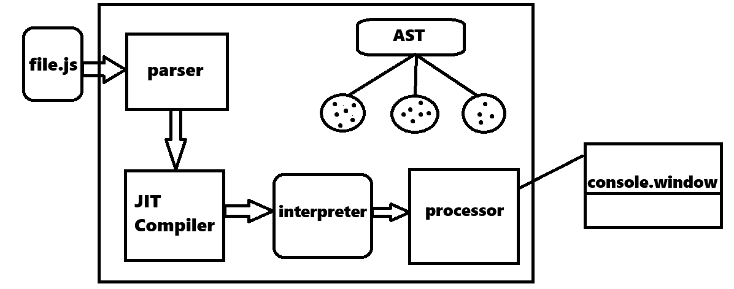
How JavaScript File sent to JavaScript Engine?
• When JS file executed on the Browser, the browser send the JS file to JS engine.
• In this process, the JS file is first sent to the PARSER and the original file structure is stored in the AST (Abstract Structure Tree).
• The PARSER divides the JS code into parts and send one-by-one to the COMPILER.
• The JIT COMPILER checks syntactical errors, then converts Source code into Byte code and sent to INTERPRETER.
• The INTERPRETER checks the Byte code line-by-line and executes each line at that time itself by sending it to the PROCESSOR.
And after that processor will send that code into console window or document for output

Output methods of JavaScript
document.write() : Prints the output in the browser window (without space)
document.writeln() : Prints the output in the browser window (with space)
console.log() : Prints the output in the developers (console) window (also called developer output)
prompt(): It is a pop-up message, takes the input from the user.
alert(): It is a pop-up message, gives the alert message to the user. (with okay option)
confirm(): It is a pop-up message, gives the confirm messages.( with okay and cancel option)

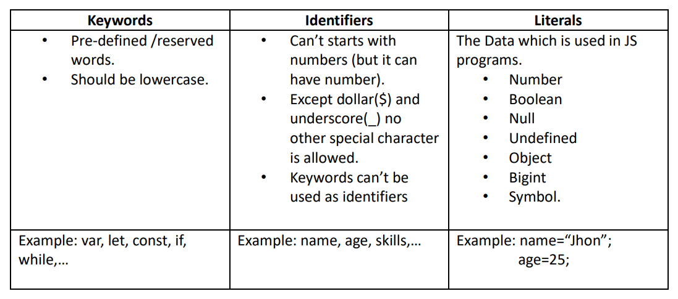
Tokens: Tokens are the smallest unit of any programming language.

Literals also called as datatypes
(Datatypes in JavaScript)
We have 8 datatypes in js those are string, number, Boolean, null, undefined, object, bigint, symbol,
- Strings – in string we store characters values like ex. name, place
- Number – in number we store number values like ex. 1, 1.1, 20,
- Boolean – this type of datatypes returns the true or false value
- Undefined – A variable in JavaScript that is without any value has a value of undefined.
- Null – In JavaScript null is "nothing". It is supposed to be something that doesn't exist. In JavaScript, the data type of null is an object
- Bigint – With BigInt, you can safely store and operate on large integers even beyond the safe integer limit for Numbers.
Ex. BigInt(“1231134324324”)
- Symbol – It represents a unique identifier and can be used in various ways. Symbols are used to create object properties, for example, when you want to assign a unique identifier to an object.
- Object- It is a non-primitive data type that consists of unordered key-value pairs. Each object may include any mix of these fundamental data types and reference data types, as objects are more complicated.

Variables

Variables are Containers for Storing Data

JavaScript Variables can be declared in 3 ways:
- var
- let
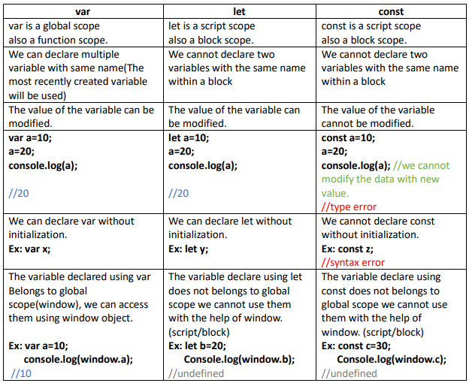
- const

Window object
When a JS file is given to browser by default a global window object is created and the reference is stored in window variable. The global object consist of pre-defined members (functions and variables) which belong to browser window.
Any member we declare var in JS file is added inside global window object by JS engine. So we can use member with the help of window.
var a=10; //var a is added into the global window object.
console.log(window.a); //10

Hoisting:
Utilizing the variable before declaration and initialization is called as Hoisting.
Hoisting can be achieved by var, because var is a global scope and global variable.
Hoisting cannot be achieved by let and const, because let and const are script scope.
Whenever we hoist var the result is undefined.
Whenever we try to hoist let and const the result is Uncaught ReferrenceError

Temporal Dead Zone (TDZ):
In the process of hoisting the time taken between Utilization of the variable before declaration and initialization.
TDZ is achieved only in let and const.
Because, whenever we try to hoist let and const the result is Uncaught ReferrenceError.
TDZ cannot be achieved in var. Because, whenever we hoist var the result is undefined.

Operators:
Operators are the symbol which performs specific operations on the operands.
Types of operators
- Arithmetic Operator
- Assignment Operator
- Relational Operator
- Logical Operator
- Ternary / Conditional Operator.

Arithmetic Operators
+ - * / %
Assignment Operators
= += -= *= /= %=
Relational Operator
< > <= >= == === !=
Logical Operator
&& | |
Ternary / Conditional Operator
(condition) ? expression1 : expression2

Conditional Statements
Conditional statements are used to perform different actions based on different conditions.
- Use if to specify a block of code to be executed, if a specified condition is true
var sir = "Rohit";
if (sir == "Rohit") {
console.log("Web tech class on");
}

- Use else to specify a block of code to be executed, if the same condition is false
var day = "monday";
if (day == "sunday") {
console.log("party");
} else {
console.log("work work work");
}

- Use else if to specify a new condition to test, if the first condition is false
var time = 17;
if (time > 1 && time < 8) {
console.log("good morning");
} else if (time > 9 && time < 15) {
console.log("good afternoon");
}
if (time > 16 && time < 24) {
console.log("good night");
}

Use switch to specify many alternative blocks of code to be executed
let month = 3;
switch (month) {
case 1:
console.log("january");
break;
case 2:
console.log("february");
break;
case 3:
console.log("march");
break;
default:
console.log("no month");}

JavaScript Functions
Functions are the block of statements which will used to perform some specific task
function get executed whenever it is called or invoked.
Function names can contain letters, digits, underscores, and dollar signs (same rules as identifiers).
The parentheses may include parameter names separated by commas:
(parameter1, parameter2, ...)
Function arguments are the values received by the function when it is invoked.
The code to be executed, by the function, is placed inside curly brackets: {}

Anonymous Function:
The function which does not have function name is called as Anonymous Function. Syntax:
function ( )
{
Statements;
}
( );

Named Function:
The function which has function name is called as Named Function.
Syntax:
function function_name ( ) {
Statements;
}
function_name( );

First class Function:
The function which is assigned as a value to a variable then the expression is called as Function with Expression.
Syntax:
var variable_name = function ( ) {
Statements;
}
variable_name( );
The function which is assigned as a value to a variable then that function is called as First Class Function. First class function is also called as First Citizen. Whatever the function it may be, if it is assigned to a variable then it is First class Function

Arrow Function:
A function having a fat arrow is called as Arrow function. To reduce the function syntax we will go for Arrow function.
Syntax:
variable_name = ( ) = > {
Statements;
} variable_name( );

Nested Function: A function inside another function is called as Nested Function. Note: One inside another function. Not many inside one function.

function function_name1 ( ) {
Statements;
function function_name2( ) {
Statements;
function function_name3( ) {
Statements;
}
function_name3( );
}
function_name2( );
}
function_name1( );

Lexical Scope: The ability of the JavaScript engine to search of the variable in the global scope when it is not available in the local scope. It is also known as Scope chain.
Closure: Closure holds the data of the parent function which is required by the child function

Immediate Invoke Function Execution:
IIFE is a function executes a function which is enclosed within the parenthesis ( ).
Syntax:
(function function_name( ){
Statements; })
( );
(function add(a, b) {
console.log(a + b);
})(10, 20);

IIFE should be called immediately right after the declaration.
IIFE cannot be reused, it is only one time usable function. \
IIFE can have function name but it cannot be called with function name.
Anonymous function, Named function, Nested function, Arrow function can be IIFE

Higher order function:
The function which takes another function as an argument is called as Higher order function.
Callback function: The function which is passed as an argument to the function
Example :
// call back function
function greet(name) {
return "Hi " + name;
}

// higher order function
function msg(greeting, name, ask,) {
console.log(greeting(name) + " " + ask);
}
msg(greet, "Sai", "how are you");
msg(greet, "dileep", "how are you");
NOTE: Higher order function accepts callback function as an argument.
Higher order function calls the call back function.

JavaScript Array
ARRAYS: - Array is collection of different elements (data). We can store more number of data and different type’s data too
Array is heterogynous in nature.
Array index value starts from 0
In JavaScript we can create array in 2 ways.
1. By using array literal
2. By using an Array constructor (using new keyword)
1)JavaScript array literal
The syntax of creating array using array literal is:
var arrayname=[value1,value2.....valueN];
values are contained inside [ ] and separated by , (comma).
The .length property returns the length of an array.
Ex:-
let numbers = [10, 20, 30, "sai", "mani", "bros"];
console.log(numbers);

2) JavaScript array constructor (new keyword):-
Here, you need to create instance of array by passing arguments in constructor so that we don't have to provide value explicitly.

Ex:-
let task = new Array(10, 20, 200);
console.log(task);

let task2 = new Array(3); it creates the size of an array and by using index numbers you can stores values
task2[0] = "sai";
task2[1] = 420;
task2[2] = 108;

Java script Array methods
push() : It will insert an element of an array at the end
trainers.push("Array data");

unshift() : It will insert an element of an array at the first
trainers.unshift("Array data");

pop() : It will remove elements of array from the end
trainers.pop();

shift() : It will remove elements of array from the start
trainers.shift();
indexOf() :It will return a index of particular element
console.log(trainers.indexOf(‘array data’));

Includes() : It will check whether the particular element is present in array or not.
console.log(trainers.includes("array data"));

Slice() : It will give slice of an array and it will not affect the original array.
console.log(trainers.slice(index value, length of array));

Splice() : It is used to add or remove elements from an array and splice will affect the original array
console.log(trainers.splice(index value, length of array, adding data));
console.log(trainers);

Join() : It is used to join all elements of an array into a string.
console.log(trainers.join());
Concat() : It is used to join/concat two or more arrays.
let num1 = [10, 20, 30];
let num2 = [40, 50, 60];
let num3 = [80,70,90]
let res = num1.concat(num2,num3);
console.log(res);

Sort() : It is used to sort array element in alphabetic order
console.log(trainers.sort());

Reverse() : It is used to reverse an array.
console.log(trainers.reverse());

Filter()
The filter() method in JavaScript is used to create a new array with all elements that pass a test specified by a provided function and it filters the array elements only. It does not modify the original array.
Example
let numbers = [1, 2, 3, 4, 5, 6, 7, 8, 9];

function isEven(number) {
return number % 2 == 0;
}

let even = numbers.filter(isEven);
console.log(even);

Map()
The map() method in JavaScript is used to create a new array by applying a function to every element in an existing array. It does not modify the original array. Instead, it returns a new array with the modified elements.
Ex:
let task = [1, 2, 3, 4, 5, 6, 7, 8, 9];

let work = task.map(number => {
return number * 2;
});
console.log(work);

Reduce() :
The reduce() method in JavaScript is used to apply a function to an accumulator and each element in an array, in order to reduce it to a single value. It iterates over each element in the array and accumulates a value based on the provided function.
Ex :
let task1 = [1, 2, 3, 4, 5, 5, 6, 6];

let task2 = task1.reduce((first, second) => {
return first + second;
}, 80);

console.log(task2);

OBJECTS IN JAVASCRIPT
A JavaScript object is an entity having state and behavior (properties and method). For example: car, pen, bike, chair, glass, keyboard, monitor etc.
JavaScript is an object-based language. Everything is an object in JavaScript.
In objects we can store the data in the form of key value pair

Creating Objects in JavaScript:
There are 3 ways to create objects.
1. By object literal.
2. By creating instance of Object directly (using new keyword).
3. By using constructor function??

1)JavaScript Object by object literal:
The syntax of creating object using object literal is given below:
<script>
let student = {
stdname: "lavan",
stdid: 143,
institute: "jspiders",
subject: "web tech",
};
</script>
As you can see, property and value is separated by : (colon)

2) By creating instance of Object with New constructor:
The syntax of creating object directly is given below:
var objectname =new Object();
Here, new keyword is used to create object.
Example of creating object directly.
<script>
let employee = new Object();
(employee.ename = "lavan"),
(employee.eid = 420),
(employee.sub = "javaking");
</script>

3) By using an constructor function:
- Here, you need to create function with arguments. Each argument value can be assigned in the current object by using this keyword.
- The this keyword refers to the current object.
The example of creating object by object constructor is given below.
<script>
function employee(ename, eid, sal, job){
this.ename = ename;
this.eid = eid;
this.sal = sal;
this.job = job;
}
let task = new employee("lavan", 420, 100000000, "donga");
let task1 = new employee("yathish", 143, 100000, "pedda donga");
console.log(task);
console.log(task1);
</script>

How to update the property value in object
let student = {
stdname: "lavan",
stdid: 143,
institute: "jspiders",
subject: "web tech",
};

student.stdname = "rohit";

How to delete the property in object with delete keyword
let student = {
stdname: "lavan",
stdid: 143
};
delete student.stdname

Objects can also have methods.
Methods are actions that can be performed on objects.

OBJECT METHODS
let employee = {
ename: "rohit",
eid: 2345,
sal: 900000,
sub: "webtech",};

1.keys : It will return array of keys
console.log(Object.keys(employee));

2.Values : It will return array of values
console.log(Object.values(employee));
3.Entries : It will return array of keys and values in objects like array format
console.log(Object.entries(employee));

4.Seal : We can only update the properties we can’t delete
console.log(Object.seal(employee));

5.isSealed : It is used to check whether the particular object is sealed or not
console.log(Object.isSealed(employee));

6.Freeze : We cannot do any modifications in an object like updation addition and deletion
console.log(Object.freeze(employee));

8.Isfrozen : It is used to check whether the particular object is frozen or not
console.log(Object.isFrozen(employee));

call() Method:
The call() method is used to invoke a function with a specified this value and a list of arguments. It allows you to call a function as if it is a method of a specific object, even if the function is not originally a method of that object.

Syntax: function.call(thisArg, arg1, arg2, ...);

apply () Method:
The apply() method is similar to call() but accepts arguments as an array or an array-like object.

Syntax: function.apply(thisArg, [argsArray]);

bind () Method:

Unlike call() and apply(), bind() does not immediately execute the function; instead, it returns a new function with the specified context and argument values.

this keyword in js

In JavaScript, this keyword refers to the current context or scope within which code is executing. Its value is determined by how a function is called, and it can dynamically change depending on the invocation context.

JAVASCRIPT STRING METHODS
// substr method – it returns the slice or existing string by using given starting index value and ending index value (n+1)
let trainer = "Ro-hit";
let extract = trainer.substring(3, 6);
console.log(extract);

// concat method – it is used to merge or concat two or more strings
let name = "Rohit";
let name2 = "Bagadi";
let fullName = name.concat(" ", name2);
console.log(fullName);

// trim method – it is used to trim or remove extra space from string
let Address = " Tirupathi";
let cut = Address.trim();
console.log(Address);
console.log(cut);

// charAt method – it returns the character based on given index value
let home = "bangalore";
let res = home.charAt(0);
console.log(res);

// replace method – it is used to replace first string in string sentence by giving another string
// replaceAll - – it is used to replace all existing string in string sentence by giving another string

let text = "plz visit my home , after coming to office";
let text1 = text.replace("home", "office");
console.log(text);
console.log(text1);

// padStart – it will add string elements in starting of given string including the given length

// padEnd method - it will add string elements in ending of given string including the given length

let number = "Rohit";
let task = number.padEnd(6, “sweety”);
console.log(task);

// repeat method – it will repeat the string based on given length
let name3 = "Sweety";
let work = name3.repeat(3000, " ");
console.log(work);

// toUpperCase and toLowercase method
let msg = "I love You";
let reply = msg.toUpperCase();
let reply2 = msg.toLowerCase();
console.log(reply);
console.log(reply2);

DATE OBJECT:-
When a date object is created, a number of methods allow you to operate on it.
Date methods allow you to get and set the year, month, day, hour, minute, second, and millisecond of date objects, using either local time or UTC time.
Date objects are created with the new Date() constructor.
In JavaScript, the Date object is used for working with dates and times. It allows you to create, manipulate, and format dates and times.
- const date = new Date();
- getFullYear(): Returns the year (4 digits) of the year
- date.getMonth(): Returns the month (0-11) of the year
- date.getDate(): Returns the day of the month (1-31) of the date.
- getDay(): Returns the day of the week (0-6) of the date (0 is Sunday, 6 is Saturday).
- getHours(): Returns the hours (0-23) of the time.
- getMinutes(): Returns the minutes (0-59) of the time.
- getSeconds(): Returns the seconds (0-59) of the time.
- getMilliseconds(): Returns the milliseconds (0-999) of the time.
- getTime(): Returns the number of milliseconds since January 1, 1970 (Unix timestamp).

MATH OBJECTS
The JavaScript Math object allows you to perform mathematical tasks on numbers.
Unlike other objects, the Math object has no constructor.
The Math object is static.
All methods and properties can be used without creating a Math object first.
The syntax for any Math property is : Math. method(number)
// ceil() - Returns x rounded up to its nearest integer
var task = Math.ceil(3.4); // 4

// floor() - Returns x rounded down to its nearest integer
var task = Math.floor(3.9); // 3

// round() - Returns x rounded to its nearest integer
var task = Math.round(3.9); // 4

// trunc() - Returns the integer part of x (new in ES6)
var task = Math.trunc(4.0); // 4

// pow() - returns the value of x to the power of y
var task = Math.pow(5, 5); // 3125

// sqrt() - returns the square root of x value
var task = Math.sqrt(4); // 2

// min and max() - returns the minimum and maximum values is passed arguments

var task = Math.min(1, 3, 5, 6, -70); // -70
var task = Math.max(1, 3, 5, 6, -70); // 6

// random() - returns the random number from 0 to 1
var task = Math.random() * 4000;
console.log(task); // generates the random number

BOM (Browser Object Model)
The Browser Object Model (BOM) allows JavaScript to "talk to" the browser.
"BOM" stands for Browser Object Model. It represents the objects that a browser provides to JavaScript to interact with the browser itself.
The BOM includes objects like:
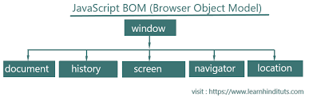

Window: The global object in a browser's environment. It represents the browser window or tab and contains properties like window. location (which gives information about the current URL), window. document (which refers to the DOM document in the current window), and many others.
- Document: Represents the DOM (Document Object Model) of a web page. It provides methods and properties to interact with the contents of the page.
- Location: Represents the current URL of the browser and allows you to interact with it.
- Navigator: Provides information about the browser itself, such as its name, version, and capabilities.
- Screen: Represents the user's screen. It provides information about the dimensions and pixel depth of the screen.
- History: Allows manipulation of the browser's history (back, forward, etc.).

Window. Screen
The window.screen object contains information about the user's screen.
The window.screen object can be written without the window prefix
Properties:
  - screen.width
  - screen.height
  - screen.availWidth
  - screen.availHeight
Window.location
The window.location object can be used to get the current page address (URL) and to redirect the browser to a new page.
Some examples:
  - window.location.href returns the href (URL) of the current page
  - window.location.hostname returns the domain name of the web host
  - window.location.pathname returns the path and filename of the current page
  - window.location.protocol returns the web protocol used (http: or https:)

Advantages

- User Interaction: BOM allows websites to show alerts, prompts, and confirmations, making them more interactive.
- Navigation Control: It also helps to manage going back or forward in your browsing history using tools like ‘history.’
- Browser Details: BOM gives information about your browser through the ‘navigator’ tool, helping to adjust content for different browsers and systems.
- Location Management: Using the ‘location’ tool, BOM lets websites change web addresses for dynamic content and easy redirection.

DOM (Document Object Model)
In JavaScript, the DOM (Document Object Model) is a programming interface for web documents. It represents the structure of a document as a tree-like model where each node is an object representing a part of the document, such as elements, attributes, and text.
When a web page is loaded, the browser creates a Document Object Model of the page.
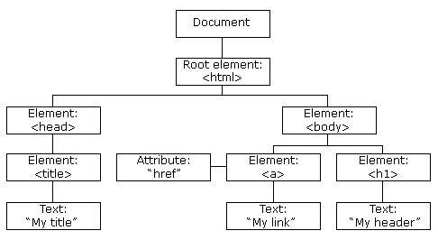
The HTML DOM model is constructed as a tree of Objects:

DOM Manipulation
- JavaScript can change all the HTML elements in the page
- JavaScript can change all the HTML attributes in the page
- JavaScript can change all the CSS styles in the page
- JavaScript can remove existing HTML elements and attributes
- JavaScript can add new HTML elements and attributes
- JavaScript can react to all existing HTML events in the page
JavaScript can create new HTML events in the page

DOM METHODS: Methods used to target HTML elements in JavaScript file
getElementById(id): This method allows you to retrieve an element from the document by its unique id.
html
<button id="btn">click me</button>;

js
let task = document.getElementById("btn");
console.log(task);

getElementsByClassName(className): This method returns a collection of all elements in the document with a specified class name.
html
<button class="btn">click me</button>;

js
let task = document.getElementsByClassName("btn");
console.log(task);

getElementsByTagName(tagName): Returns a collection of elements with the specified tag name.
html
<button class="btn">click me</button>;

js
let task = document.getElementsByTagName("button");
console.log(task);

querySelector(selector): Returns the first element that matches a specified CSS selector.
html
<button class="btn">click me</button>;

js
let task = document.querySelector(".btn");
console.log(task);

querySelectorAll(selector): Returns a NodeList of all elements that match a specified CSS selector.
html
<button class="btn">click me</button>;
<button class="btn">click me</button>;
<button class="btn">click me</button>;

js
let task = document.querySelectorAll(".btn");
console.log(task);

What is collection in HTML?
An HTMLCollection is an array-like collection (list) of HTML elements. The elements in a collection can be accessed by index (starts at 0). The length Property returns the number of elements in the collection.

What is Nodelist ?
They are a collection of nodes or elements, just like the books by the same author are a collection. In technical terms, a NodeList is a group of nodes extracted from the Document Object Model (DOM).

What is the difference between NodeList and array?
A NodeList may look like an array, but it is not. You can loop through a NodeList and refer to its nodes by index. But, you cannot use Array methods like push(), pop(), or join() on a NodeList.
A NodeList is a collection of document nodes (element nodes, attribute nodes, and text nodes). NodeList items can only be accessed by their index number.
Changing HTML Elements
Changing inner text with innerHTML
html
<h1 id="hello"> hello </h1>

let task = document.getElementById('hello')
task.innerHTML = 'hi im rohit'

Changing styling with style and property
html
< h1 id = "hello" >hello</h1 >
js
let task = document.getElementById("hello");
task.style.backgroundColor = "red";

Changing attribute with setAttribute()
html
< h1 id = "h1" >hello</ h1>

let task = document.getElementById("h1");
attribute name and value 8j
task.setAttribute("class", "heading");
console.log(task);

Creating html element by Dom in js
First we have to create one element with createElement method and that we have to append that element on body with appendChild()
Ex.
let ele = document.createElement("section");
document.body.appendChild(ele);
console.log(ele);
ele.innerHTML= 'im section'

createElement()
This method in JavaScript is used to create a new HTML element with a specified tag name. The method takes a single argument, which is the tag name of the element to be created. For example, document. createElement("div") creates a new div element.

appendchild()
The appendChild method in JavaScript is used to add a new child node to an existing parent node. means the created html element we will add to body of our web page document

Deleting elements

let task = document.getElementById(`list')
task.removeChild(task)

removeChild()
the method removes a specified child node from the current node.
Tip: The removed child node can be inserted later into any element in the same document.

DOM Event Listener
The addEventListener() method attaches an event handler to the specified element
The first parameter is the type of the event (like "click" or "mouseover" or any other HTML DOM Event.)
The second parameter is the function we want to call when the event occurs.

Ex:
element.addEventListener("click", function(){
alert("Hello World!");
});
DOM Events
Event: An action performed by the user on the webpage is known as an event
A JavaScript can be executed when an event occurs, like when a user clicks on an HTML element.
In the web development process, events refer to user actions, such as such as clicking a button, minimizing the browser window, or submitting a form. Event handling in JavaScript and JavaScript frameworks allows us to respond to user actions and interactions and create dynamic and interactive websites
The addEventListener() method attaches an event handler to an element without overwriting existing event handlers. You can add many event handlers to one element. You can add many event handlers of the same type to one element, i.e two "click" events.
- Click
- Mouseover
- Mouseout

Javascript promises
JavaScript Promise are easy to manage when dealing with multiple asynchronous operations
- The promise constructor takes only one argument which is a callback function
- The callback function takes two arguments, resolve and reject

Perform operations inside the callback function and if everything went well then call resolve.

If desired operations do not go well then call reject.

let task = new Promise((resolve, reject) => {
setTimeout(() => {
let trainer = "rohit";
if (trainer == "rohit") {
resolve();
} else {
reject();
}
}, 2000);
});

task
.then(() => {
console.log("nice");
})
.catch(() => {
console.log("bad");
});

When promise get full filled or resolved. Then method will get executed
When promise get rejected. Catch method will get executed
Time delays
setTimeOut() and setInterval() are two functions in js allows to schedule tasks to be executed at later time. Used for animations, polling data from server and other asynchronous tasks.
setTimeOut() :
Runs the code with time delay
Syntax : window.setTimeOut( function , delay ) ;
- function: The function you want to execute.
- delay: The amount of time (in milliseconds) before the function is executed
setInterval() :
The function similar to setTimeOut, but it schedules a function to be executed repeatedly at specified interval.
Syntax : window.setInterval( function , delay ) ;
- function: The function you want to execute.
- delay: The amount of time (in milliseconds) before the function is executed

JSON (Java Script Object Notation)
It is format of storing and transporting data.
It is used when the data is sent from server to web page
It is a popular data format for developers because of its human readable text, light weight which requires less coding and faster process
The JSON format is syntactically similar to the code for creating JavaScript objects. Because of this, a JavaScript program can easily convert JSON data into JavaScript objects.
Since the format is text only, JSON data can easily be sent between computers, and used by any programming language.
JavaScript has a built in function for converting JSON strings into JavaScript objects:

Syntax of JSON
Data is in Key value pairs
Data is separated by ‘,’
Curly braces holds objects
[ ]---holds array
In JavaScript, there are two main methods used to work with JSON (JavaScript Object Notation):
1. JSON.Stringify () : used to convert normal object to JSON format
2.JSON.parse(): Used to convert JSON format of data to normal object
Advantages of JSON
- Human readable format
- Support all popular programming languages
- Easy to organize and access
- It is light weight

